**ACKNOWLEDGEMENT**

With immense pleasure, we are presenting “ **Milk Dairy Management System** ” project report as part of the curriculum of ‘Bachelor of Computer Application’ we wish to thanks all the people who gave us unending support.

We express our profound thanks to our Prof . Barage S.B., project guide and all those who have indirectly guided and help for stand all those who have indirectly guided and help us in preparation of this project.

Mr. Sangram Patil

Mr. Akash Pol

**INDEX**

|  |  |  |
| --- | --- | --- |
| **Sr. No.** | **Title** | **Page No.** |
| 1 | Introduction of system  - Existing system  -Scope of system  -Operating environment  -Need of computerization |  |
| 2 | Analysis and design  -Requirement analysis  -Feasibility study  -Hardware and Software Requirement |  |
| 3 | Flow Diagram  -Data Flow Diagram  -Entity Relationship Diagram |  |
| 4 | Database Design  -Table design |  |
| 5 | Design |  |
| 6 | Coding |  |
| 7 | Report |  |
| 8 | Advantages &Limitation |  |
| 9 | Conclusion |  |
| 10 | References |  |

**Introduction**

* **Existing System**

With the change in looks of the “ Milk Dairy ” world over and the concept convenience being built in at Milk Dairy detail outlet. The milk dairies are rapidly going for automatic to manage their business with easy.

Milk Dairy Management outlet going through change and required Milk Dairy Management System software which can help them to automation.

Increase efficiency and provide instant milk collection report & MDMS for timely decision making…..

* **Scope of the System**

I want this system to make the life easier by getting reports and bills. It saves lot of time and energy in order to make schedule from his busy hours. As this system is very cost effective user need not spend extra money. It can analyse the people around it and create a good image of them by wishing the people for very important moment in their life. This system helps it to make better in arena of relatives, friends as well as business partners. This system includes future occasion dates by analysing these dates he can schedule itself for upcoming events and prepared for that.

This system has strong report support to report it can see history of event. It can also keep track of important date and help to fix meeting or appointment for the business.

**-Objectives**

This project will serve the following objectives.

1. Add and maintain records customers
2. Add and maintain customer bank details.
3. Keeps daily and monthly records of milk collection.
4. Set and update daily fat rate.
5. Generate bills.
6. Provide a convenient solution of billing pattern.
7. Provide financial report to the owner.

**-Need of project**

There are various drawbacks in manual system to overcome all this drawbacks. There is need of projects.

Computer is an electronic device which can storage large amount of data. There are facilities for protection of data on disk, which are preventing entry of unauthorized user.

Manually there may be more chances of mistake while amount calculation like total amount of calculation etc. But all these calculations are when performed on computer we get more accuracy and first calculation. Computer means device that operate upon information data computer very depending on data it is easy to guaranty report which reduces manpower efforts.

Following point gives the dear India about the need of computerization.

**-Time Saving**

Due to manual lot of time is wasted unnecessary, because of clearness of works & stock is maintained very difficult. But by using computerized system is very easy**.**

**Analysis and Design**

**Requirement Analysis**

Any software development life cycle first require systematic gathering and analysis data. To collect information for developing system we had done in three ways as

1. **Onsite observation**

It means observing the format of how the record is saved, how the billing is formed, transaction process etc.

**2. Going through manual documents**

Documents such as bills, purchase order, forms etc. were examined and we took its data where it was required.

**Feasibility Study**

It is useful to evaluate cost and benefit of the system requested. It tries to anticipate future scenario of software development. There are three aspect of feasibility study.

It is do not determine the possibility of either improved the existence system.

1. **Technical Feasibility**

It always focuses on the existing computer hardware, software and personal. Here the available hardware and software is considered. It also includes the need for more hardware or software or personnel and possibility installing such a facility.

Accordingly the hardware and software installed and computer is upgraded.

1. **Economic Feasibility**

It considers the cost and benefit of the proposed project. The benefit is always expected to be over the cost.

1. **Operational Feasibility**

It considers the acceptability of the system. A project may be rejected due to operational non-feasibility if cheque whether the system will be used if it is developed.

**Hardware and Software**

**Hardware requirement:-**

Processor :- Pentium 3 or 4 & above

RAM-: 1 GB and above

Hard disk-: Min 20 GB

**Software requirement:-**

For this system following software is used

Operating System-: Windows 7/ above

Front End :- Visual Studio 2010 ( vb.net )

Back End :- MS-SQL server 2008

Report:-SAP (Crystal report)

**Flow Diagram**

**-Data Flow Diagram**



**-Entity Relationship Diagram**



**Database Design**

**-Table design**

**1. Customer_Master**

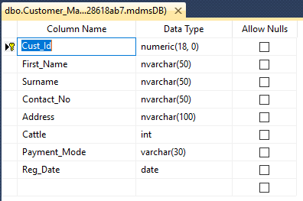

1. **Bank_Account_Master**

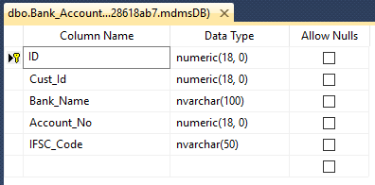

**3.Bill _Master**

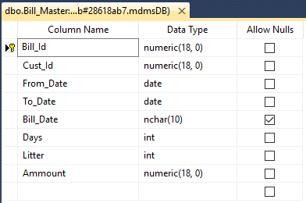

1. **Cattle _Master**

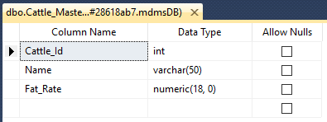

1. **Collection _Master**

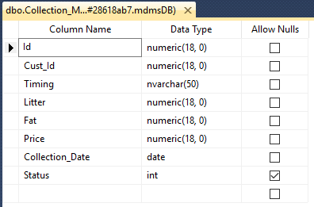

1. **User _Master**

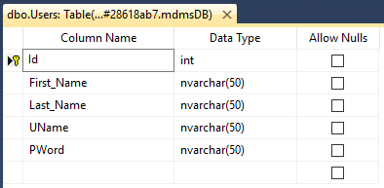

**Design**

**Login Form**

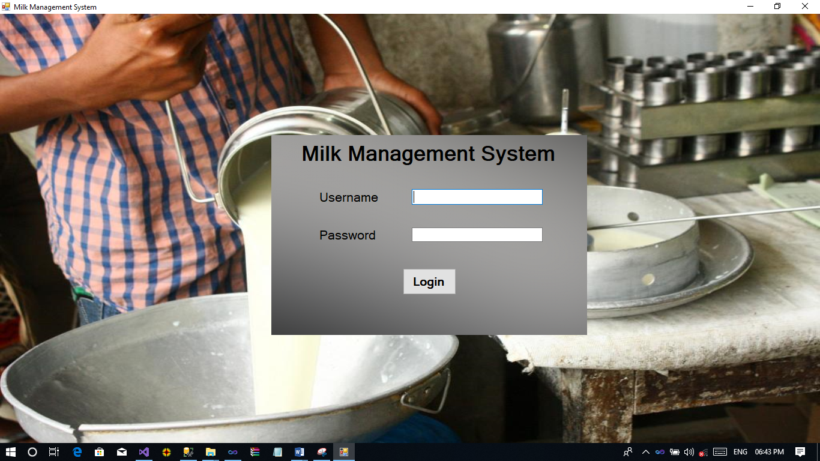

**Main MDI Form**

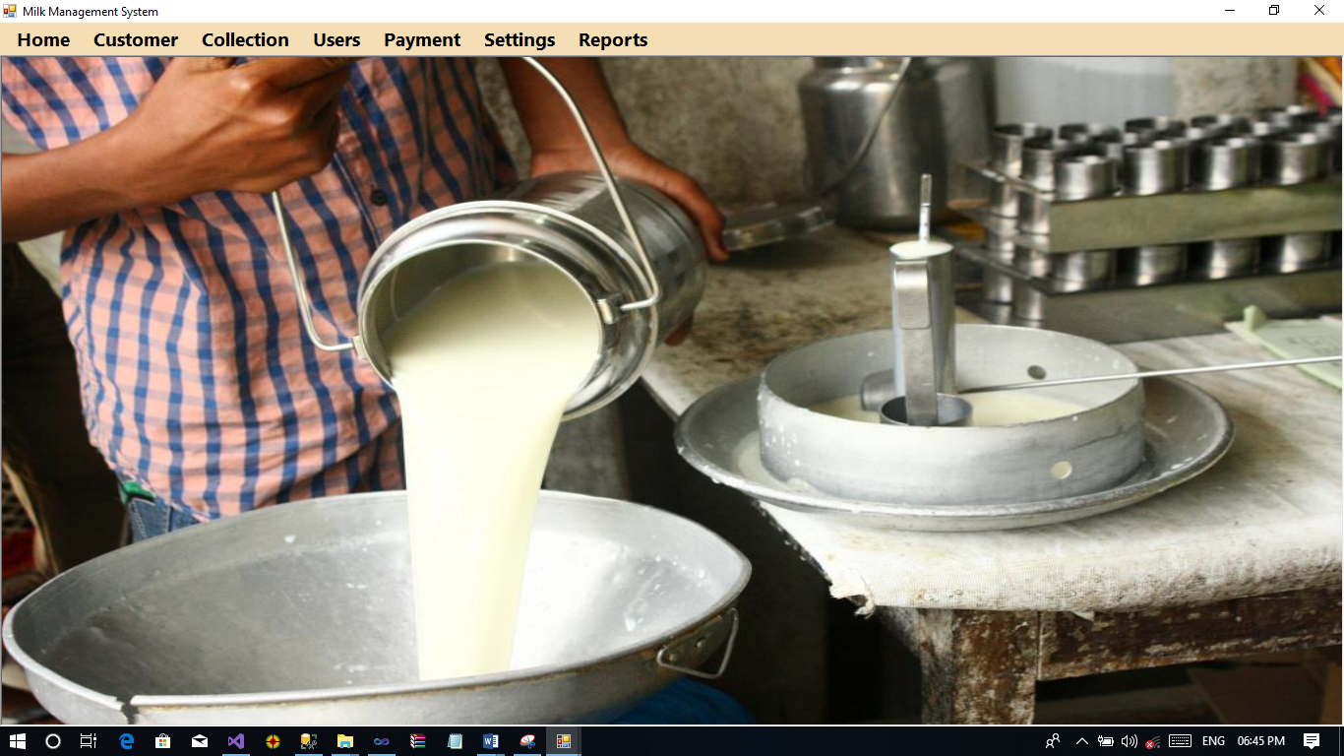

**Add Customer**

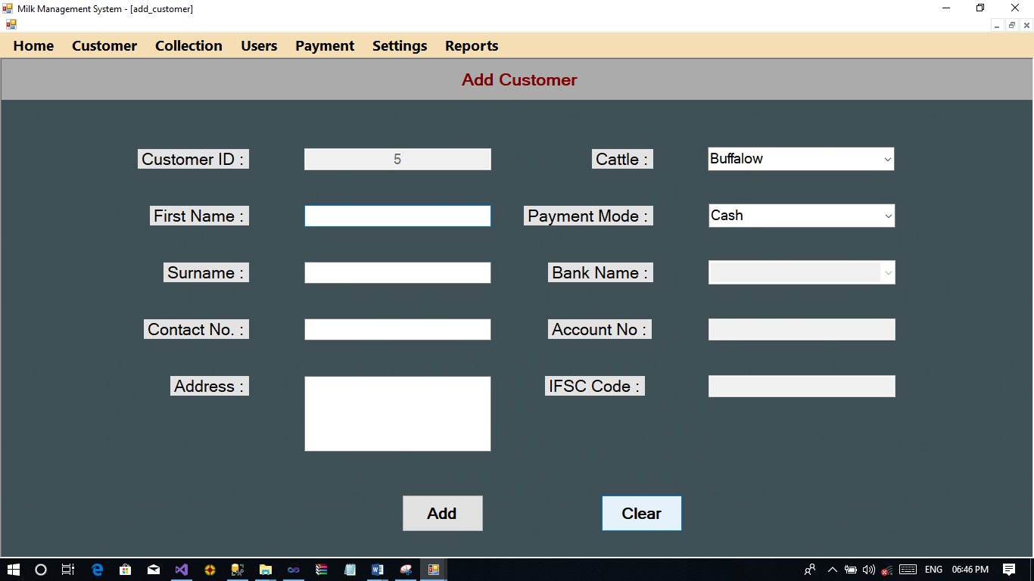

**Update Customer**

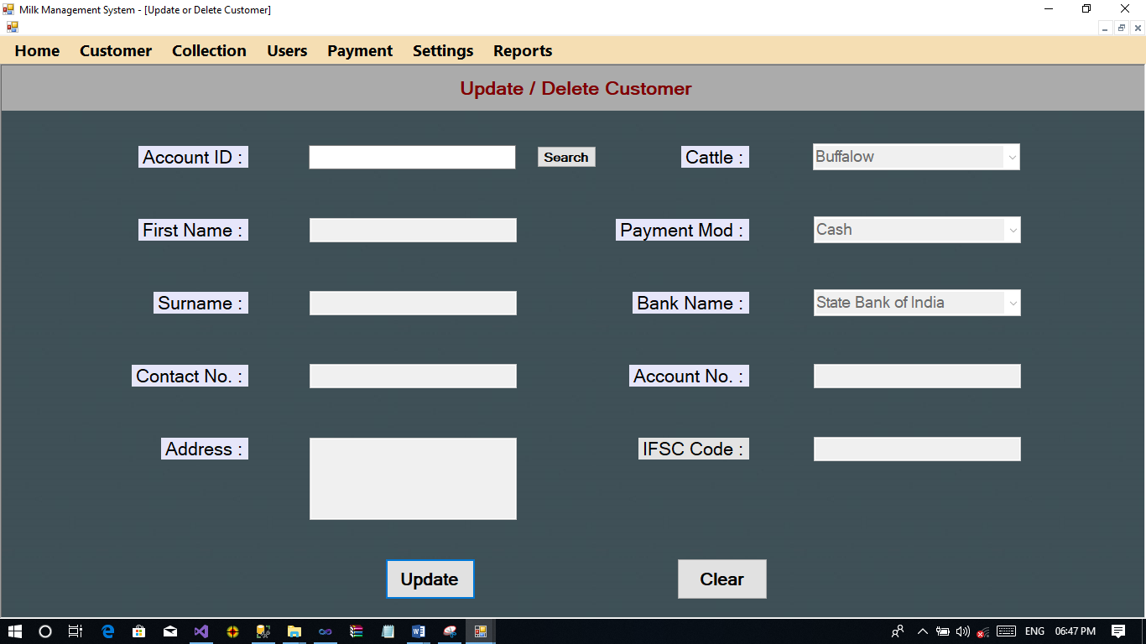

**Customer Information**

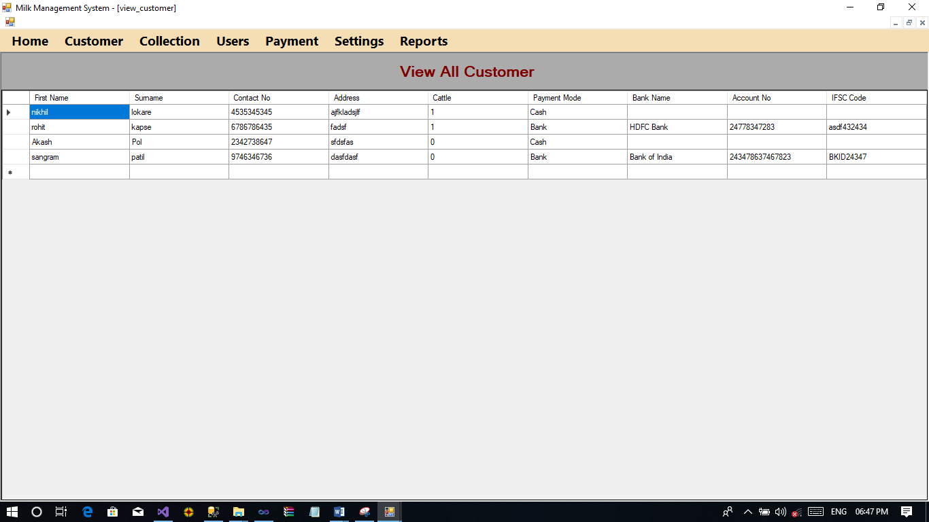

**Milk Colleaction**

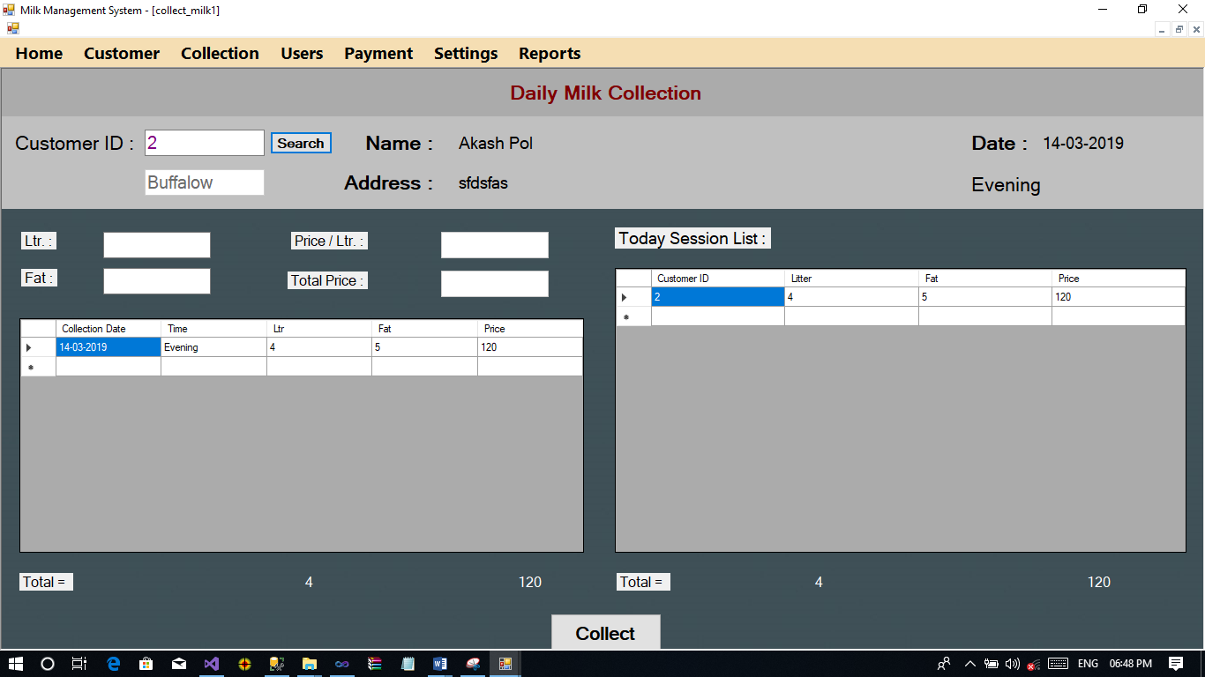

**Add User**

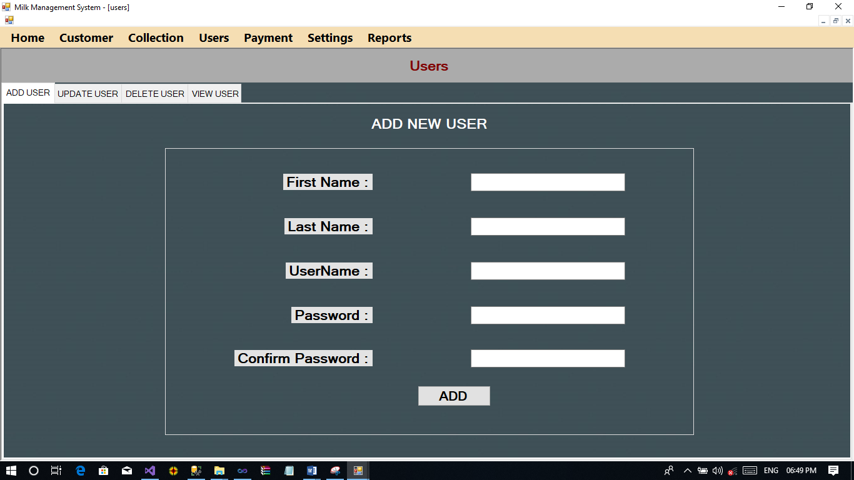

**Edit User**

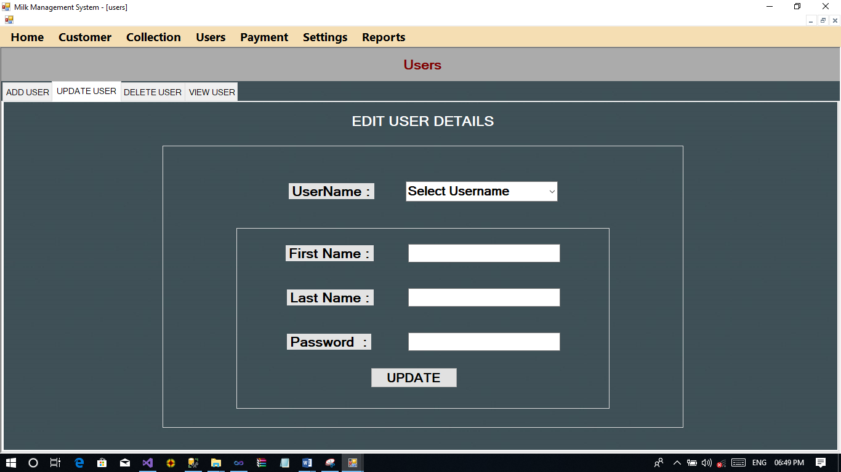

**Delete User**

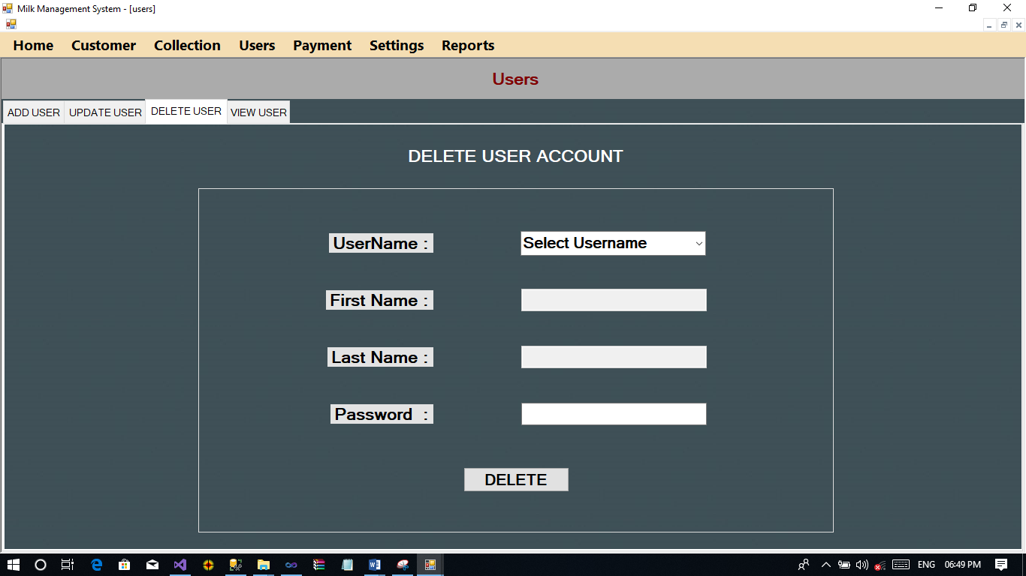

**View User Account**

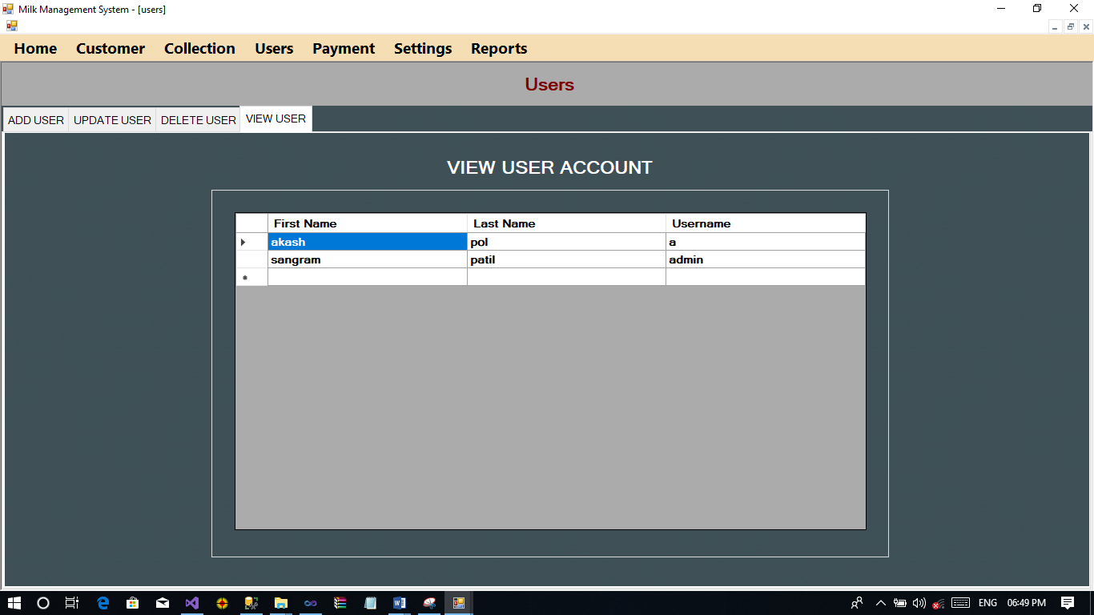

**Payment**

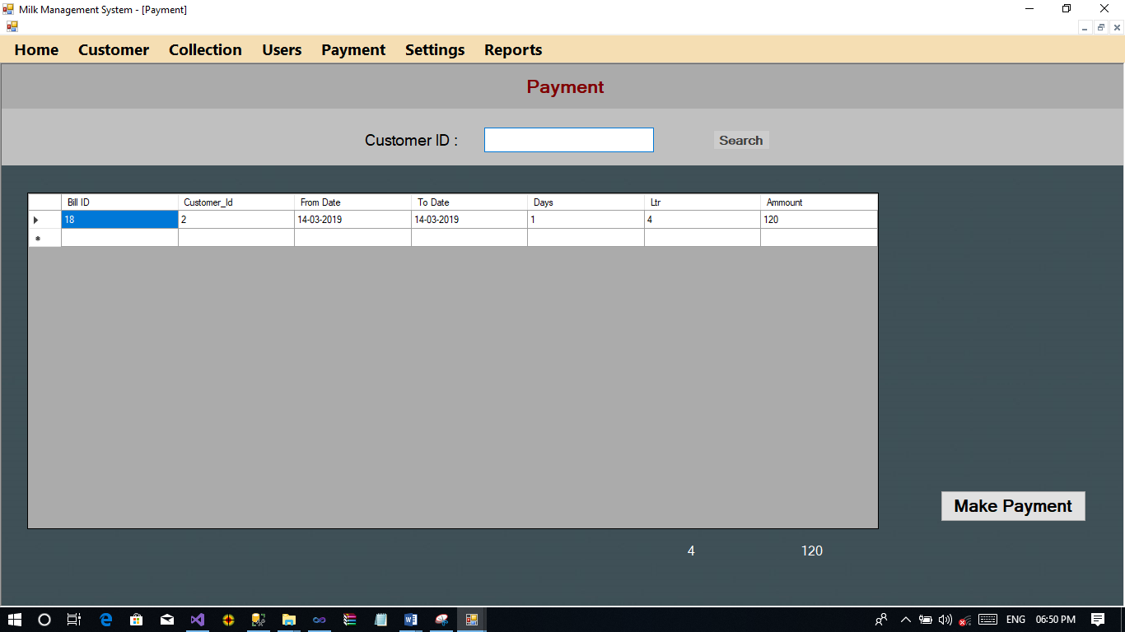

**Fat Rate Setting**

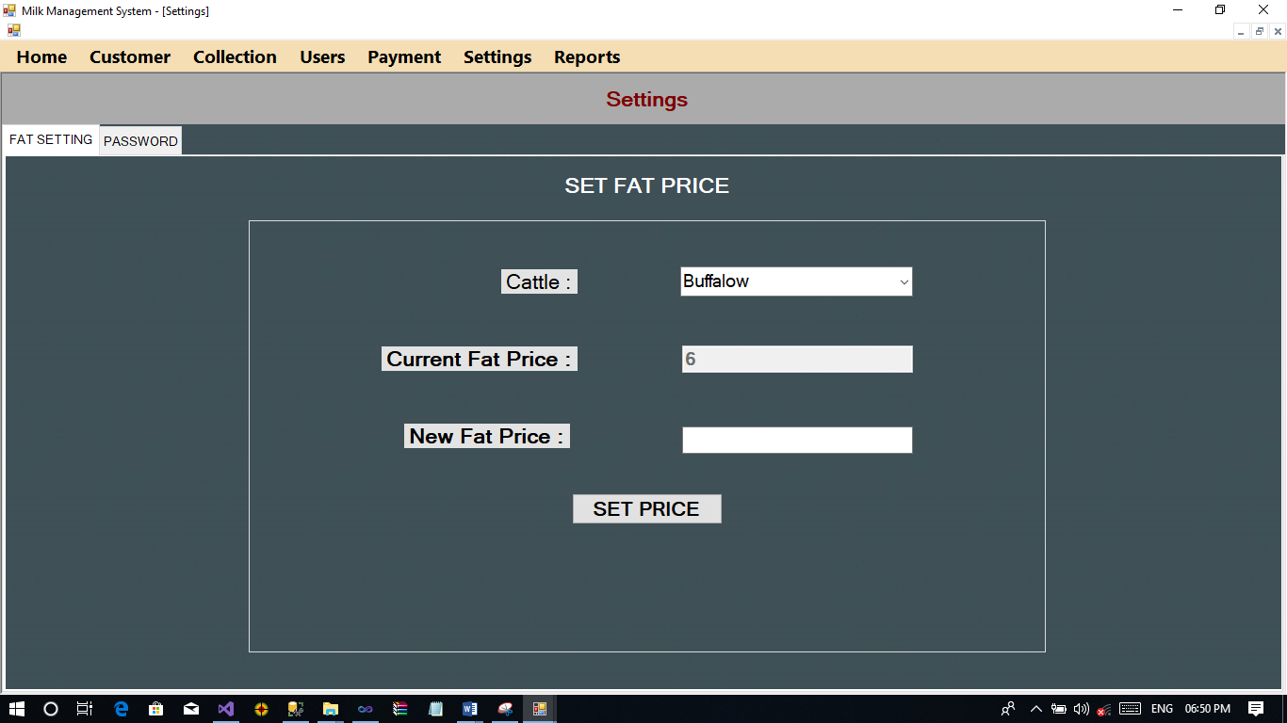

**Change Current User Password**

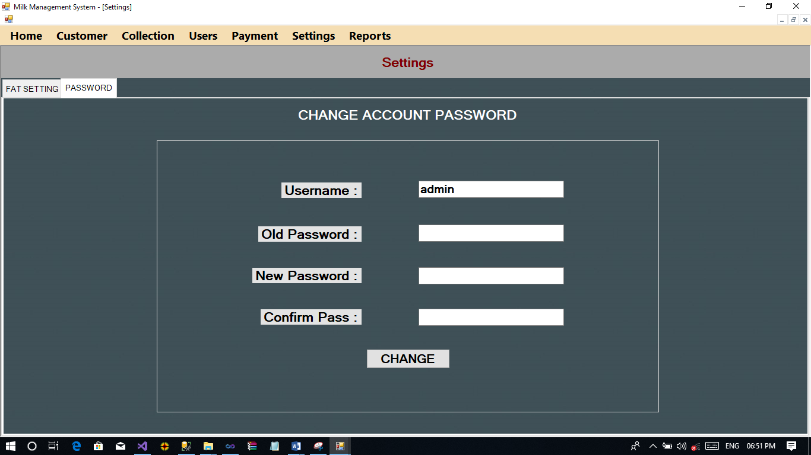

**Coding**

**Login Form**

Public Class Login

Private Sub btnLogin_Click(sender As Object, e As EventArgs) Handles btnLogin.Click

Query_Select("select * from Users where UName like '" & Tb_Username.Text & "' and PWord like '" & Tb_Password.Text & "'")

If dr.Read Then

user_id = Tb_Username.Text

Tb_Username.Clear()

Tb_Password.Clear()

MDIParent_Main.Show()

Else

MessageBox.Show("Username or Password Does Not Match")

End If

End Sub

End Class

**Main MDI Form**

Public Class MDIParent_Main

Private Sub FatRateToolStripMenuItem_Click(ByVal sender As Object, ByVal e As EventArgs)

End Sub

Private Sub HomeToolStripMenuItem_Click(ByVal sender As System.Object, ByVal e As System.EventArgs) Handles HomeToolStripMenuItem.Click

If ActiveMdiChild IsNot Nothing Then

ActiveMdiChild.Close()

End If

End Sub

Private Sub NewCustomerToolStripMenuItem_Click(ByVal sender As System.Object, ByVal e As System.EventArgs) Handles NewCustomerToolStripMenuItem.Click

If ActiveMdiChild IsNot Nothing Then

ActiveMdiChild.Close()

End If

add_customer.MdiParent = Me

add_customer.WindowState = FormWindowState.Maximized

add_customer.Show()

End Sub

Private Sub UpdateCustomerToolStripMenuItem_Click(ByVal sender As System.Object, ByVal e As System.EventArgs) Handles UpdateCustomerToolStripMenuItem.Click

If ActiveMdiChild IsNot Nothing Then

ActiveMdiChild.Close()

End If

update_delete_customer.MdiParent = Me

update_delete_customer.WindowState = FormWindowState.Maximized

update_delete_customer.Show()

End Sub

Private Sub ViewCustomerToolStripMenuItem_Click(ByVal sender As System.Object, ByVal e As System.EventArgs) Handles ViewCustomerToolStripMenuItem.Click

If ActiveMdiChild IsNot Nothing Then

ActiveMdiChild.Close()

End If

view_customer.MdiParent = Me

view_customer.WindowState = FormWindowState.Maximized

view_customer.Show()

End Sub

Private Sub CollectMilkToolStripMenuItem_Click(ByVal sender As System.Object, ByVal e As System.EventArgs) Handles CollectMilkToolStripMenuItem.Click

If ActiveMdiChild IsNot Nothing Then

ActiveMdiChild.Close()

End If

collect_milk.MdiParent = Me

collect_milk.WindowState = FormWindowState.Maximized

collect_milk.Show()

End Sub

Private Sub ToolStripMenuItem1_Click(ByVal sender As System.Object, ByVal e As System.EventArgs) Handles ToolStripMenuItem1.Click

If ActiveMdiChild IsNot Nothing Then

ActiveMdiChild.Close()

End If

users.MdiParent = Me

users.WindowState = FormWindowState.Maximized

users.Show()

End Sub

Private Sub HelpToolStripMenuItem_Click(ByVal sender As System.Object, ByVal e As System.EventArgs) Handles HelpToolStripMenuItem.Click

If ActiveMdiChild IsNot Nothing Then

ActiveMdiChild.Close()

End If

payment.MdiParent = Me

payment.WindowState = FormWindowState.Maximized

payment.Show()

End Sub

Private Sub HelpToolStripMenuItem1_Click(ByVal sender As System.Object, ByVal e As System.EventArgs) Handles HelpToolStripMenuItem1.Click

If ActiveMdiChild IsNot Nothing Then

ActiveMdiChild.Close()

End If

settings.MdiParent = Me

settings.WindowState = FormWindowState.Maximized

settings.Show()

End Sub

Private Sub MDIParent_Main_Load(sender As Object, e As EventArgs) Handles MyBase.Load

If user_id = "admin" Then

ToolStripMenuItem1.Enabled = True

Else

ToolStripMenuItem1.Enabled = False

End If

End Sub

Private Sub CustomerToolStripMenuItem1_Click(ByVal sender As System.Object, ByVal e As System.EventArgs) Handles CustomerToolStripMenuItem1.Click

ReportFormCustomer.MdiParent = Me

ReportFormCustomer.WindowState = FormWindowState.Maximized

ReportFormCustomer.Show()

End Sub

Private Sub ToolStripMenuItem2_Click(ByVal sender As System.Object, ByVal e As System.EventArgs) Handles ToolStripMenuItem2.Click

ReportFormCustomerBank.MdiParent = Me

ReportFormCustomerBank.WindowState = FormWindowState.Maximized

ReportFormCustomerBank.Show()

End Sub

Private Sub PaymentToolStripMenuItem_Click(ByVal sender As System.Object, ByVal e As System.EventArgs) Handles PaymentToolStripMenuItem.Click

ReportFormReportPaid.MdiParent = Me

ReportFormReportPaid.WindowState = FormWindowState.Maximized

ReportFormReportPaid.Show()

End Sub

Private Sub PaymentUnpaidToolStripMenuItem_Click(ByVal sender As System.Object, ByVal e As System.EventArgs) Handles PaymentUnpaidToolStripMenuItem.Click

ReportFormReportUnpaid.MdiParent = Me

ReportFormReportUnpaid.WindowState = FormWindowState.Maximized

ReportFormReportUnpaid.Show()

End Sub

Private Sub MilkCollectionToolStripMenuItem_Click(ByVal sender As System.Object, ByVal e As System.EventArgs) Handles MilkCollectionToolStripMenuItem.Click

ReportFormMilkCollection.MdiParent = Me

ReportFormMilkCollection.WindowState = FormWindowState.Maximized

ReportFormMilkCollection.Show()

End Sub

Private Sub MDIParent_Main_Leave(sender As Object, e As EventArgs) Handles MyBase.Leave

user_id = ""

End Sub

End Class

**Add Customer**

Public Class add_customer

Private Sub Button1_Click(ByVal sender As System.Object, ByVal e As System.EventArgs) Handles Button1.Click

If cbPaymentMode.SelectedIndex = 0 Then

If tbFirstName.Text <> "" And tbSurname.Text <> "" And tbContactNo.Text <> "" And tbAddress.Text <> "" Then

If Query_Inser_Update_Delete("insert into Customer_Master values(" & tbCustId.Text & ",'" & tbFirstName.Text & "','" & tbSurname.Text & "','" & tbContactNo.Text & "','" & tbAddress.Text & "'," & cbCattle.SelectedIndex & ", '" & cbPaymentMode.SelectedItem.ToString & "','" & Today.ToString("yyyy-MM-dd") & "')") Then

MessageBox.Show("Customer Successfully Added")

tbCustId.Text = Double.Parse(tbCustId.Text) + 1

tbFirstName.Clear()

tbSurname.Clear()

tbContactNo.Clear()

tbAddress.Clear()

cbCattle.SelectedIndex = 0

cbPaymentMode.SelectedIndex = 0

cbBankName.Text = ""

tbIFSCCode.Clear()

tbAccountNo.Clear()

Else

MessageBox.Show("Can't Add Customer")

End If

Else

MessageBox.Show("Please First Fill All Fields")

End If

ElseIf cbPaymentMode.SelectedIndex = 1 Then

If tbFirstName.Text <> "" And tbSurname.Text <> "" And tbContactNo.Text <> "" And tbAddress.Text <> "" And cbBankName.Text <> "" And tbAccountNo.Text <> "" And tbIFSCCode.Text <> "" Then

If Query_Inser_Update_Delete("insert into Customer_Master values(" & tbCustId.Text & ",'" & tbFirstName.Text & "','" & tbSurname.Text & "','" & tbContactNo.Text & "','" & tbAddress.Text & "'," & cbCattle.SelectedIndex & ", '" & cbPaymentMode.SelectedItem.ToString & "','" & Today.ToString("yyyy-MM-dd") & "')") And Query_Inser_Update_Delete("insert into Bank_Account_Master(Cust_Id,Bank_Name,Account_No,IFSC_Code) values(" & tbCustId.Text & ",'" & cbBankName.Text & "','" & tbAccountNo.Text & "','" & tbIFSCCode.Text & "')") Then

MessageBox.Show("Customer Successfully Added")

tbCustId.Text = Double.Parse(tbCustId.Text) + 1

tbFirstName.Clear()

tbSurname.Clear()

tbContactNo.Clear()

tbAddress.Clear()

cbCattle.SelectedIndex = 0

cbPaymentMode.SelectedIndex = 0

cbBankName.Text = ""

tbIFSCCode.Clear()

Else

MessageBox.Show("Can't Add Customer")

End If

Else

MessageBox.Show("Please First Fill All Fields")

End If

End If

End Sub

Private Sub add_customer_Load(ByVal sender As System.Object, ByVal e As System.EventArgs) Handles MyBase.Load

Query_Select("select Name from Cattle_Master")

While dr.Read

cbCattle.Items.Add(dr(0))

End While

cbCattle.SelectedIndex = 0

cbPaymentMode.SelectedIndex = 0

If Not IsDBNull(Query_ExecuteScalar("select MAX(Cust_Id) from Customer_Master")) Then

tbCustId.Text = Double.Parse(Query_ExecuteScalar("select MAX(Cust_Id) from Customer_Master")) + 1

Else

tbCustId.Text = 1

End If

End Sub

Private Sub cbPaymentMode_SelectedIndexChanged(sender As Object, e As EventArgs) Handles cbPaymentMode.SelectedIndexChanged

If cbPaymentMode.SelectedIndex = 0 Then

cbBankName.Enabled = False

tbAccountNo.Enabled = False

tbIFSCCode.Enabled = False

ElseIf cbPaymentMode.SelectedIndex = 1 Then

cbBankName.Enabled = True

tbAccountNo.Enabled = True

tbIFSCCode.Enabled = True

End If

End Sub

Private Sub tbContactNo_Leave(sender As Object, e As EventArgs) Handles tbContactNo.Leave

If Not IsNumeric(tbContactNo.Text) Then

MessageBox.Show("Please enter valid contact no")

tbContactNo.Clear()

End If

End Sub

Private Sub tbAccountNo_Leave(sender As Object, e As EventArgs) Handles tbAccountNo.Leave

If Not IsNumeric(tbAccountNo.Text) Then

MessageBox.Show("Please enter valid Account no")

tbAccountNo.Clear()

End If

End Sub

Private Sub Button2_Click(sender As Object, e As EventArgs) Handles Button2.Click

tbFirstName.Clear()

tbSurname.Clear()

tbContactNo.Clear()

tbAddress.Clear()

cbCattle.SelectedIndex = 0

cbPaymentMode.SelectedIndex = 0

cbBankName.Text = ""

tbIFSCCode.Clear()

End Sub

End Class

**Update Customer**

Public Class update_delete_customer

Dim mode As String

Private Sub btnUpdate_Click(sender As Object, e As EventArgs) Handles btnUpdate.Click

If cbPaymentMode.SelectedIndex = 0 Then

If tbFirstName.Text <> "" And tbSurname.Text <> "" And tbContactNo.Text <> "" And tbAddress.Text <> "" And cbPaymentMode.Text <> "" Then

If Query_Inser_Update_Delete("update Customer_Master set First_Name='" & tbFirstName.Text & "',Surname='" & tbSurname.Text & "',Contact_No=" & tbContactNo.Text & ",Address='" & tbAddress.Text & "',Payment_Mode='" & cbPaymentMode.Text & "' where Cust_Id=1") Then

MessageBox.Show("Customer Successfully Updated")

Else

MessageBox.Show("Can't Update Customer")

End If

Else

MessageBox.Show("Please Fill all mandotory fields!!!!!!!!!!")

End If

ElseIf cbPaymentMode.SelectedIndex = 1 Then

If tbFirstName.Text <> "" And tbSurname.Text <> "" And tbContactNo.Text <> "" And tbAddress.Text <> "" And cbPaymentMode.Text <> "" And cbBankName.Text <> "" And tbAccountNo.Text <> "" And tbIFSCCode.Text <> "" Then

Query_Select("select Payment_Mode from Customer_Master where Cust_Id = " & tbCustId.Text & "")

If dr.Read Then

If dr(0) = "Cash" Then

If Query_Inser_Update_Delete("update Customer_Master set First_Name='" & tbFirstName.Text & "',Surname='" & tbSurname.Text & "',Contact_No=" & tbContactNo.Text & ",Address='" & tbAddress.Text & "',Payment_Mode='" & cbPaymentMode.Text & "' where Cust_Id=1") And Query_Inser_Update_Delete("insert into Bank_Account_Master(Cust_Id,Bank_Name,Account_No,IFSC_Code) values(" & tbCustId.Text & ",'" & cbBankName.Text & "','" & tbAccountNo.Text & "','" & tbIFSCCode.Text & "')") Then

MessageBox.Show("Customer Successfully Updated")

Else

MessageBox.Show("Can't Update Customer")

End If

ElseIf dr(0) = "Bank" Then

If Query_Inser_Update_Delete("update Customer_Master set First_Name='" & tbFirstName.Text & "',Surname='" & tbSurname.Text & "',Contact_No=" & tbContactNo.Text & ",Address='" & tbAddress.Text & "',Payment_Mode='" & cbPaymentMode.Text & "' where Cust_Id=1") And Query_Inser_Update_Delete("update Bank_Account_Master set Bank_Name='" & cbBankName.Text & "',Account_No=" & tbAccountNo.Text & ",IFSC_Code='" & tbIFSCCode.Text & "' where Cust_Id = " & tbCustId.Text & "") Then

MessageBox.Show("Customer Successfully Updated")

Else

MessageBox.Show("Can't Update Customer")

End If

End If

End If

Else

MessageBox.Show("Please Fill all mandotory fields!!!!!!!!!!")

End If

End If

End Sub

Private Sub btnSearch_Click(sender As Object, e As EventArgs) Handles btnSearch.Click

If IsNumeric(tbCustId.Text) Then

Query_Select("select * from Customer_Master where Cust_Id=" & tbCustId.Text & "")

If dr.Read Then

MessageBox.Show("Customer Found")

tbFirstName.Text = dr(1)

tbSurname.Text = dr(2)

tbContactNo.Text = dr(3)

tbAddress.Text = dr(4)

If 0 = dr(5) Then

cbCattle.SelectedIndex = 0

ElseIf 1 = dr(5) Then

cbCattle.SelectedIndex = 1

End If

mode = dr(6)

cbPaymentMode.Text = dr(6)

Query_Select("select * from Bank_Account_Master where Cust_Id=" & tbCustId.Text & "")

If dr.Read Then

cbBankName.Text = dr(2)

tbAccountNo.Text = dr(3)

tbIFSCCode.Text = dr(4)

End If

enable()

Else

MessageBox.Show("Customer Not found")

End If

End If

End Sub

Private Sub Panel1_Paint(sender As Object, e As PaintEventArgs) Handles Panel1.Paint

End Sub

Private Sub tbAccountNo_Leave(sender As Object, e As EventArgs) Handles tbAccountNo.Leave

If Not IsNumeric(tbAccountNo.Text) Then

tbAccountNo.Clear()

MessageBox.Show("Please Enter Valid Account NUmber")

End If

End Sub

Private Sub tbContactNo_Leave(sender As Object, e As EventArgs) Handles tbContactNo.Leave

If Not IsNumeric(tbContactNo.Text) Then

tbContactNo.Clear()

MessageBox.Show("Please Enter Valid Mobile NUmber")

End If

End Sub

Private Sub btnClere_Click(sender As Object, e As EventArgs) Handles btnClere.Click

clr()

disable()

End Sub

Private Sub enable()

tbFirstName.Enabled = True

tbSurname.Enabled = True

tbContactNo.Enabled = True

tbAddress.Enabled = True

cbPaymentMode.Enabled = True

cbBankName.Enabled = True

tbAccountNo.Enabled = True

tbIFSCCode.Enabled = True

End Sub

Private Sub disable()

tbFirstName.Enabled = False

tbSurname.Enabled = False

tbContactNo.Enabled = False

tbAddress.Enabled = False

cbPaymentMode.Enabled = False

cbBankName.Enabled = False

tbAccountNo.Enabled = False

tbIFSCCode.Enabled = False

End Sub

Private Sub clr()

tbFirstName.Clear()

tbSurname.Clear()

tbContactNo.Clear()

tbAddress.Clear()

cbPaymentMode.SelectedIndex = 0

cbBankName.SelectedIndex = 0

tbAccountNo.Clear()

tbIFSCCode.Clear()

End Sub

Private Sub tbCustId_TextChanged(sender As Object, e As EventArgs) Handles tbCustId.TextChanged

clr()

disable()

End Sub

Private Sub update_delete_customer_Load(sender As Object, e As EventArgs) Handles MyBase.Load

Query_Select("select Name from Cattle_Master")

While dr.Read

cbCattle.Items.Add(dr(0))

End While

cbCattle.SelectedIndex = 0

cbPaymentMode.SelectedIndex = 0

cbBankName.SelectedIndex = 0

End Sub

End Class

**Customer Information**

Public Class view_customer

Private Sub view_customer_Load(sender As Object, e As EventArgs) Handles MyBase.Load

Query_FillDG("select c.First_Name as 'First Name',c.Surname,c.Contact_No as 'Contact No',c.Address,c.Cattle,c.Payment_Mode as 'Payment Mode',b.Bank_Name as 'Bank Name',b.Account_No as 'Account No',b.IFSC_Code as 'IFSC Code' from Customer_Master c left join Bank_Account_Master b on c.Cust_Id = b.Cust_Id order by c.Cust_Id desc")

DataGridView1.DataSource = dt

da.Update(dt)

End Sub

End Class

**Milk Collection Form**

Public Class collect_milk

Private Sub Button2_Click(sender As Object, e As EventArgs) Handles Button2.Click

Query_Select("select c.First_Name,c.Surname,c.Address,cm.Name from Customer_Master c inner join Cattle_Master cm on c.Cattle=cm.Cattle_Id where c.Cust_Id=" & tbCustId.Text & "")

If dr.Read Then

lbName.Text = dr(0) + " " + dr(1)

lbAddress.Text = dr(2)

tbCattle.Text = dr(3)

fill_dg_single()

total_all()

Else

MessageBox.Show("Customer Not Found")

End If

End Sub

Private Sub collect_milk_Load(sender As Object, e As EventArgs) Handles MyBase.Load

lbDate.Text = Date.Today.Date

If Hour(DateAndTime.TimeOfDay) <= 13 Then

lbTiming.Text = "Morning"

ElseIf Hour(DateAndTime.TimeOfDay) > 13 Then

lbTiming.Text = "Evening"

lbName.Text = ""

lbAddress.Text = ""

tbCattle.Clear()

total_all()

End If

fill_dg_all()

End Sub

Private Sub btnCollect_Click(sender As Object, e As EventArgs) Handles btnCollect.Click

If IsNumeric(tbLtr.Text) And IsNumeric(tbFat.Text) Then

If Query_Inser_Update_Delete("insert into Collection_Master(Cust_Id,Timing,Litter,Fat,Price,Collection_Date,Status) values(" & tbCustId.Text & ",'" & lbTiming.Text & "'," & tbLtr.Text & "," & tbFat.Text & "," & tbTotalPrice.Text & ",'" & Today.ToString("yyyy-MM-dd") & "',0)") Then

MessageBox.Show("Milk Collected")

fill_dg_single()

fill_dg_all()

total_all()

Query_Select("select * from Bill_Master where Cust_Id =" & tbCustId.Text & " and Bill_Date is null")

If dr.Read Then

'MessageBox.Show("Found")

Query_Select("select max(Collection_Date),COUNT(distinct(Collection_Date)),SUM(Litter),SUM(Price) from Collection_Master where Status=0 and Cust_Id=" & tbCustId.Text & "")

If dr.Read Then

Dim d As Date

d = dr(0)

Dim tdays As Integer = dr(1)

Dim tlitter As Integer = dr(2)

Dim tprice As Integer = dr(3)

If Query_Inser_Update_Delete("update Bill_Master set To_Date='" & d.ToString("yyyy-MM-dd") & "', Days=" & tdays & ",Litter=" & tlitter & ",Ammount=" & tprice & " where Cust_Id=" & tbCustId.Text & " and Bill_Date is null") Then

'MessageBox.Show("done")

Else

' MessageBox.Show("not done")

End If

End If

Else

If Query_Inser_Update_Delete("insert into Bill_Master(Cust_Id,From_Date,To_Date,Days,Litter,Ammount) select " & tbCustId.Text & ",min(Collection_Date),max(Collection_Date),COUNT(distinct(Collection_Date)),SUM(Litter),SUM(Price) from Collection_Master where Status=0 and Cust_Id=" & tbCustId.Text & "") Then

'MessageBox.Show("done")

Else

'MessageBox.Show("not done")

End If

End If

Else

MessageBox.Show("Pleas First Fill All Fields!!")

End If

End If

End Sub

Private Sub tbLtr_Leave(sender As Object, e As EventArgs) Handles tbLtr.Leave

If IsNumeric(tbLtr.Text) Then

If IsNumeric(tbFat.Text) Then

cal()

End If

Else

MessageBox.Show("Please Enter Valid Values!!!")

End If

End Sub

Private Sub tbFat_Leave(sender As Object, e As EventArgs) Handles tbFat.Leave

If IsNumeric(tbFat.Text) Then

If IsNumeric(tbLtr.Text) Then

cal()

End If

Else

MessageBox.Show("Please Enter Valid Values!!!")

End If

End Sub

Private Sub cal()

Query_Select("select Fat_Rate from Cattle_Master where Name='" & tbCattle.Text & "'")

If dr.Read Then

tbPricePLtr.Text = (tbFat.Text) * dr(0)

tbTotalPrice.Text = (tbPricePLtr.Text) * (tbLtr.Text)

End If

End Sub

Private Sub fill_dg_single()

Query_FillDG("select Collection_Date as 'Collection Date',Timing as 'Time',Litter as 'Ltr',Fat,Price from Collection_Master where Status=0 and Cust_Id=" & tbCustId.Text & " order by id desc")

dgSingleCustomer.DataSource = dt

da.Update(dt)

Query_Select("select sum(Litter),sum(Price) from Collection_Master where Cust_Id=" & tbCustId.Text & " and Status=0")

If dr.Read And Not IsDBNull(dr(0)) And Not IsDBNull(dr(1)) Then

lbSCTLtr.Text = dr(0)

lbSCTPrice.Text = dr(1)

End If

End Sub

Private Sub fill_dg_all()

Query_FillDG("select Cust_Id as 'Customer ID',Litter,Fat,Price from Collection_Master where Status=0 and Collection_Date = '" & Today.ToString("yyyy-MM-dd") & "' order by id desc")

dgAllCustomer.DataSource = dt

da.Update(dt)

End Sub

Private Sub tbCustId_TextChanged(sender As Object, e As EventArgs) Handles tbCustId.TextChanged

clr()

dgSingleCustomer.DataSource = vbNull

End Sub

Private Sub total_all()

Query_Select("select SUM(Litter) from Collection_Master where Collection_Date='" & Today.ToString("MM-dd-yyyy") & "' and Status=0")

If dr.Read Then

If Not IsDBNull(dr(0)) Then

lbAllLtr.Text = dr(0)

Else

lbAllLtr.Text = "0"

End If

End If

Query_Select("select SUM(Price) from Collection_Master where Collection_Date='" & Today.ToString("MM-dd-yyyy") & "' and Status=0")

If dr.Read Then

If Not IsDBNull(dr(0)) Then

lbAllPrice.Text = dr(0)

Else

lbAllPrice.Text = "0"

End If

End If

End Sub

Private Sub clr()

lbName.Text = ""

lbAddress.Text = ""

tbCattle.Clear()

dt.Clear()

fill_dg_all()

tbLtr.Clear()

tbFat.Clear()

tbPricePLtr.Clear()

tbTotalPrice.Clear()

lbSCTLtr.Text = ""

lbSCTPrice.Text = ""

End Sub

End Class

**User Manipulation**

Public Class users

Private Sub users_Load(sender As Object, e As EventArgs) Handles MyBase.Load

Query_Select("select UName from Users")

cbEUUsername.Items.Add("Select Username")

cbDUUsername.Items.Add("Select Username")

While dr.Read

cbEUUsername.Items.Add(dr(0))

cbDUUsername.Items.Add(dr(0))

End While

cbEUUsername.SelectedIndex = 0

cbDUUsername.SelectedIndex = 0

fill_dg()

End Sub

Private Sub btnadduser_Click(sender As Object, e As EventArgs) Handles btnadduser.Click

If tbANUFN.Text <> "" And tbANULN.Text <> "" And tbANUserName.Text <> "" And tbANUPassword.Text <> "" Then

If tbANUPassword.Text = tbADUPassword2.Text Then

If Query_Inser_Update_Delete("insert into Users(First_Name,Last_Name,UName,PWord) values('" & tbANUFN.Text & "','" & tbANULN.Text & "','" & tbANUserName.Text & "','" & tbANUPassword.Text & "')") Then

MessageBox.Show("User Created")

cbDUUsername.Items.Clear()

cbEUUsername.Items.Clear()

Query_Select("select UName from Users")

cbEUUsername.Items.Add("Select Username")

cbDUUsername.Items.Add("Select Username")

While dr.Read

cbEUUsername.Items.Add(dr(0))

cbDUUsername.Items.Add(dr(0))

End While

cbEUUsername.SelectedIndex = 0

cbDUUsername.SelectedIndex = 0

fill_dg()

Else

MessageBox.Show("Can't Add")

End If

Else

MessageBox.Show("Password Did Not Match!!!")

End If

Else

MessageBox.Show("Please Fill All Fields!!!")

End If

End Sub

Private Sub cbEUUsername_SelectedIndexChanged(sender As Object, e As EventArgs) Handles cbEUUsername.SelectedIndexChanged

If cbEUUsername.Items.Contains(cbEUUsername.Text) Then

If cbEUUsername.SelectedIndex > 0 Then

Query_Select("select * from Users where UName='" & cbEUUsername.Text & "'")

If dr.Read Then

tbEUFN.Text = dr(1)

tbEULN.Text = dr(2)

End If

End If

Else

MessageBox.Show("Wrong Username!!")

End If

End Sub

Private Sub cbEUUsername_Leave(sender As Object, e As EventArgs) Handles cbEUUsername.Leave

If cbEUUsername.Items.Contains(cbEUUsername.Text) Then

If cbEUUsername.SelectedIndex > 0 Then

Query_Select("select * from Users where UName='" & cbEUUsername.Text & "'")

If dr.Read Then

tbEUFN.Text = dr(1)

tbEULN.Text = dr(2)

btnEdit.Enabled = True

End If

End If

Else

MessageBox.Show("Wrong Username!!")

cbEUUsername.SelectedIndex = 0

btnEdit.Enabled = False

End If

End Sub

Private Sub btnEdit_Click(sender As Object, e As EventArgs) Handles btnEdit.Click

If tbEUFN.Text <> "" And tbEULN.Text <> "" And tbEUPassword.Text <> "" Then

Query_Select("select * from Users where UName='" & cbEUUsername.Text & "' and PWord='" & tbEUPassword.Text & "'")

If dr.Read Then

If Query_Inser_Update_Delete("update Users set First_Name='" & tbEUFN.Text & "',Last_Name='" & tbEULN.Text & "' where UName='" & cbEUUsername.Text & "'") Then

MessageBox.Show("User Updated")

tbEUFN.Clear()

tbEULN.Clear()

tbEUPassword.Clear()

fill_dg()

Else

MessageBox.Show("Wrong Password!!!")

End If

Else

MessageBox.Show("Wrong Password!!!")

End If

Else

MessageBox.Show("Please Fill All Fields!!!")

End If

End Sub

Private Sub cbDUUsername_Leave(sender As Object, e As EventArgs) Handles cbDUUsername.Leave

If cbDUUsername.Items.Contains(cbDUUsername.Text) Then

If cbDUUsername.SelectedIndex > 0 Then

Query_Select("select * from Users where UName='" & cbDUUsername.Text & "'")

If dr.Read Then

tbDUFirstName.Text = dr(1)

tbDULastName.Text = dr(2)

btnDelete.Enabled = True

End If

End If

Else

MessageBox.Show("Wrong Username!!")

cbDUUsername.SelectedIndex = 0

btnDelete.Enabled = False

End If

End Sub

Private Sub cbDUUsername_SelectedIndexChanged(sender As Object, e As EventArgs) Handles cbDUUsername.SelectedIndexChanged

If cbDUUsername.Items.Contains(cbDUUsername.Text) Then

If cbDUUsername.SelectedIndex > 0 Then

Query_Select("select * from Users where UName='" & cbDUUsername.Text & "'")

If dr.Read Then

tbDUFirstName.Text = dr(1)

tbDULastName.Text = dr(2)

btnDelete.Enabled = True

End If

End If

Else

MessageBox.Show("Wrong Username!!")

cbDUUsername.SelectedIndex = 0

btnDelete.Enabled = False

End If

End Sub

Private Sub btnDelete_Click(sender As Object, e As EventArgs) Handles btnDelete.Click

If tbDUFirstName.Text <> "" And tbDULastName.Text <> "" And tbDUPassword.Text <> "" Then

If Query_Inser_Update_Delete("delete from Users where UName='" & cbDUUsername.Text & "' and PWord='" & tbDUPassword.Text & "'") Then

MessageBox.Show("User Deleted")

tbDUFirstName.Clear()

tbDULastName.Clear()

tbDUPassword.Clear()

cbDUUsername.Items.Clear()

cbEUUsername.Items.Clear()

Query_Select("select UName from Users")

cbEUUsername.Items.Add("Select Username")

cbDUUsername.Items.Add("Select Username")

While dr.Read

cbEUUsername.Items.Add(dr(0))

cbDUUsername.Items.Add(dr(0))

End While

cbEUUsername.SelectedIndex = 0

cbDUUsername.SelectedIndex = 0

fill_dg()

Else

MessageBox.Show("Wrong Password!!!")

End If

Else

MessageBox.Show("Please First Fill All Fields")

End If

End Sub

Private Sub fill_dg()

Query_FillDG("select First_Name as 'First Name',Last_Name as 'Last Name',UName as 'Username' from Users")

DataGridView1.DataSource = dt

da.Update(dt)

End Sub

End Class

**Settings**

Public Class settings

Private Sub tabControl1_Click(sender As Object, e As EventArgs) Handles tabControl1.Click

End Sub

Private Sub settings_Load(sender As Object, e As EventArgs) Handles MyBase.Load

Query_Select("select Name from Cattle_Master")

While dr.Read()

cbCattle.Items.Add(dr(0))

End While

cbCattle.SelectedIndex = 0

tbUsername.Text = user_id

End Sub

Private Sub cbCattle_SelectedIndexChanged(sender As Object, e As EventArgs) Handles cbCattle.SelectedIndexChanged

Query_Select("select Fat_Rate from Cattle_Master where Name='" & cbCattle.SelectedItem.ToString & "'")

If dr.Read Then

tbCureentFatPrice.Text = dr(0)

End If

End Sub

Private Sub btnSetPrice_Click(sender As Object, e As EventArgs) Handles btnSetPrice.Click

If IsNumeric(tbNewFatPrice.Text) Then

If Query_Inser_Update_Delete("update Cattle_Master set Fat_Rate=" & tbNewFatPrice.Text & " where Name='" & cbCattle.Text & "'") Then

MessageBox.Show("Fat Rate Changed")

tbNewFatPrice.Clear()

Query_Select("select Fat_Rate from Cattle_Master where Name='" & cbCattle.SelectedItem.ToString & "'")

If dr.Read Then

tbCureentFatPrice.Text = dr(0)

End If

End If

Else

MessageBox.Show("Please Enter Valid Rate Value")

tbNewFatPrice.Clear()

End If

End Sub

Private Sub tbNewFatPrice_Leave(sender As Object, e As EventArgs) Handles tbNewFatPrice.Leave

If Not IsNumeric(tbNewFatPrice.Text) Then

MessageBox.Show("Please Enter Valid Rate Value")

tbNewFatPrice.Clear()

End If

End Sub

Private Sub btnEdit_Click(sender As Object, e As EventArgs) Handles btnEdit.Click

If tbUsername.Text <> "" And tbOldPassword.Text <> "" And tbNewPassword.Text <> "" And tbConfirmPassword.Text <> "" Then

Query_Select("select * from Users where UName='" & tbUsername.Text & "' and PWord='" & tbOldPassword.Text & "'")

If dr.Read Then

If tbNewPassword.Text = tbConfirmPassword.Text Then

If Query_Inser_Update_Delete("update Users set PWord='" & tbNewPassword.Text & "' where UName='" & tbUsername.Text & "' and PWord='" & tbOldPassword.Text & "'") Then

MessageBox.Show("Password Changed")

Else

MessageBox.Show("Can't Update")

End If

Else

MessageBox.Show("Password did not match!!!")

End If

Else

MessageBox.Show("Wrong Password")

End If

Else

MessageBox.Show("Please fill all ther fields first!!")

End If

End Sub

End Class

**Payment**

Public Class payment

Private Sub payment_Load(sender As Object, e As EventArgs) Handles MyBase.Load

fill_dg("")

' total("")

End Sub

Private Sub tbCustomerId_TextChanged(sender As Object, e As EventArgs) Handles tbCustomerId.TextChanged

If tbCustomerId.Text = "" Then

fill_dg("")

' total("")

btnSearch.Enabled = False

ElseIf IsNumeric(tbCustomerId.Text) Then

btnSearch.Enabled = True

btnMakePayment.Enabled = False

End If

End Sub

Private Function fill_dg(ByVal s As String)

Query_FillDG("select Bill_Id as 'Bill ID',Cust_Id as 'Customer_Id',From_Date as 'From Date',To_Date as 'To Date',Days,Litter as 'Ltr',Ammount from Bill_Master where Cust_Id like '%" & s & "%' and Bill_Date is null")

DataGridView1.DataSource = dt

da.Update(dt)

total(s)

End Function

Private Sub btnSearch_Click(sender As Object, e As EventArgs) Handles btnSearch.Click

If IsNumeric(tbCustomerId.Text) Then

fill_dg(tbCustomerId.Text)

btnMakePayment.Enabled = True

End If

End Sub

Private Sub btnMakePayment_Click(sender As Object, e As EventArgs) Handles btnMakePayment.Click

If tbCustomerId.Text = "" Then

If Query_Inser_Update_Delete("update Collection_Master set Status = 1 where Status=0") And Query_Inser_Update_Delete("update Bill_Master set Bill_Date='" & Today.ToString("yyyy-MM-dd") & "' where Bill_Date is null") Then

MessageBox.Show("Payment Successfull")

fill_dg("")

End If

ElseIf IsNumeric(tbCustomerId.Text) Then

If Query_Inser_Update_Delete("update Collection_Master set Status = 1 where Status=0 and Cust_Id=" & tbCustomerId.Text & "") And Query_Inser_Update_Delete("update Bill_Master set Bill_Date='" & Today.ToString("yyyy-MM-dd") & "' where Bill_Date is null and Cust_Id=" & tbCustomerId.Text & "") Then

MessageBox.Show("Payment Successfull")

fill_dg("")

tbCustomerId.Clear()

End If

End If

End Sub

Private Function total(ByVal s As String)

Query_Select("select sum(Litter),sum(Ammount) from Bill_Master where Cust_Id like '%" & s & "%' and Bill_Date is null")

If dr.Read Then

If Not IsDBNull(dr(0)) And Not IsDBNull(dr(1)) Then

lbLtr.Text = dr(0)

lbPrice.Text = dr(1)

End If

End If

End Function

End Class

**Customer Report**

Imports System.Data.SqlClient

Public Class ReportFormCustomer

Private Sub ReportFormCustomer_Load(ByVal sender As System.Object, ByVal e As System.EventArgs) Handles MyBase.Load

Dim cr As New CrystalReportCustomer

Dim Str As String = "select * from Customer_Master c inner join Cattle_Master cm on c.Cattle=cm.Cattle_Id"

con_close()

con_open()

da = New SqlDataAdapter(Str, con)

Dim ds As New DataSet

da.Fill(ds, "ViewCustomer")

cr.SetDataSource(ds)

CrystalReportViewer1.ReportSource = cr

CrystalReportViewer1.Refresh()

cr.Refresh()

End Sub

End Class

**Customer Bank Account Details Report**

Imports System.Data.SqlClient

Public Class ReportFormCustomerBank

Private Sub ReportFormCustomerBank_Load(ByVal sender As System.Object, ByVal e As System.EventArgs) Handles MyBase.Load

Dim cr As New CrystalReportCustomerBank

Dim Str As String = "select * from Customer_Master c inner join Bank_Account_Master cm on c.Cust_Id=cm.Cust_Id"

con_close()

con_open()

da = New SqlDataAdapter(Str, con)

Dim ds As New DataSet

da.Fill(ds, "ViewCustomer")

cr.SetDataSource(ds)

CrystalReportViewer1.ReportSource = cr

CrystalReportViewer1.Refresh()

cr.Refresh()

End Sub

End Class

**Paid Payment Report**

Imports System.Data.SqlClient

Public Class ReportFormReportPaid

Dim mont As String = ""

Dim yr As String = ""

Private Sub ReportFormReportPaid_Load(ByVal sender As System.Object, ByVal e As System.EventArgs) Handles MyBase.Load

Query_Select("select distinct(YEAR(Bill_Date)) from Bill_Master")

ComboBox1.Items.Add("All")

While dr.Read

If Not IsDBNull(dr(0)) And dr(0).ToString <> "1900" Then

ComboBox1.Items.Add(dr(0))

End If

End While

ComboBox2.Items.Add("All")

For i As Integer = 1 To 12

ComboBox2.Items.Add(MonthName(i))

Next

ComboBox2.SelectedIndex = 0

ComboBox1.SelectedIndex = 0

End Sub

Private Sub Button1_Click_1(ByVal sender As System.Object, ByVal e As System.EventArgs) Handles Button1.Click

Dim cr As New CrystalReportBillPaid

Dim Str As String = "select * from Customer_Master c inner join Bill_Master b on c.Cust_Id=b.Cust_Id inner join Cattle_Master cm on c.Cattle=cm.Cattle_Id where b.Bill_Date is not null and year(b.Bill_Date) like '%" & yr & "%' and MONTH(b.Bill_Date) like '%" & mont & "%'"

con_close()

con_open()

da = New SqlDataAdapter(Str, con)

Dim ds As New DataSet

da.Fill(ds, "ViewBill")

cr.SetDataSource(ds)

CrystalReportViewer1.ReportSource = cr

CrystalReportViewer1.Refresh()

cr.Refresh()

End Sub

Private Sub ComboBox2_SelectedIndexChanged(ByVal sender As System.Object, ByVal e As System.EventArgs) Handles ComboBox2.SelectedIndexChanged

If ComboBox2.SelectedIndex = 0 Then

mont = ""

ElseIf ComboBox2.SelectedIndex > 0 Then

mont = ComboBox2.SelectedIndex

End If

End Sub

Private Sub ComboBox1_SelectedIndexChanged(ByVal sender As System.Object, ByVal e As System.EventArgs) Handles ComboBox1.SelectedIndexChanged

If ComboBox1.SelectedIndex = 0 Then

yr = ""

ElseIf ComboBox1.SelectedIndex > 0 Then

yr = ComboBox1.Text

End If

End Sub

End Class

**Unpaid Payment Report**

Imports System.Data.SqlClient

Public Class ReportFormReportUnpaid

Private Sub ReportFormReportPaid_Load(ByVal sender As System.Object, ByVal e As System.EventArgs) Handles MyBase.Load

Dim cr As New CrystalReportUnpaid

Dim Str As String = "select * from Customer_Master c inner join Bill_Master b on c.Cust_Id=b.Cust_Id inner join Cattle_Master cm on c.Cattle=cm.Cattle_Id where b.Bill_Date is null"

con_close()

con_open()

da = New SqlDataAdapter(Str, con)

Dim ds As New DataSet

da.Fill(ds, "ViewBill")

cr.SetDataSource(ds)

CrystalReportViewer1.ReportSource = cr

CrystalReportViewer1.Refresh()

cr.Refresh()

End Sub

End Class

**Milk Collection Report**

Imports System.Data.SqlClient

Public Class ReportFormMilkCollection

Dim mont As String = ""

Dim yr As String = ""

Private Sub ReportFornMilkCollection_Load(ByVal sender As System.Object, ByVal e As System.EventArgs) Handles MyBase.Load

Query_Select("select distinct(YEAR(Collection_Date)) from Collection_Master")

ComboBox1.Items.Add("All")

While dr.Read

If Not IsDBNull(dr(0)) And dr(0).ToString <> "1900" Then

ComboBox1.Items.Add(dr(0))

End If

End While

ComboBox2.Items.Add("All")

For i As Integer = 1 To 12

ComboBox2.Items.Add(MonthName(i))

Next

ComboBox2.SelectedIndex = 0

ComboBox1.SelectedIndex = 0

End Sub

Private Sub Button1_Click(ByVal sender As System.Object, ByVal e As System.EventArgs) Handles Button1.Click

Dim cr As New CrystalReportMilkCollection

Dim Str As String = "select * from Customer_Master c inner join Collection_Master cm on c.Cust_Id =cm.Cust_Id inner join Cattle_Master ctm on c.Cattle=ctm.Cattle_Id where year(cm.Collection_Date) like '%" & yr & "%' and MONTH(cm.Collection_Date) like '%" & mont & "%'"

con_close()

con_open()

da = New SqlDataAdapter(Str, con)

Dim ds As New DataSet

da.Fill(ds, "ViewCollection")

cr.SetDataSource(ds)

CrystalReportViewer1.ReportSource = cr

CrystalReportViewer1.Refresh()

cr.Refresh()

End Sub

Private Sub ComboBox2_SelectedIndexChanged(ByVal sender As System.Object, ByVal e As System.EventArgs) Handles ComboBox2.SelectedIndexChanged

If ComboBox2.SelectedIndex = 0 Then

mont = ""

ElseIf ComboBox2.SelectedIndex > 0 Then

mont = ComboBox2.SelectedIndex

End If

End Sub

Private Sub ComboBox1_SelectedIndexChanged(ByVal sender As System.Object, ByVal e As System.EventArgs) Handles ComboBox1.SelectedIndexChanged

If ComboBox1.SelectedIndex = 0 Then

yr = ""

ElseIf ComboBox1.SelectedIndex > 0 Then

yr = ComboBox1.Text

End If

End Sub

End Class

**Report**

**Customer Report**

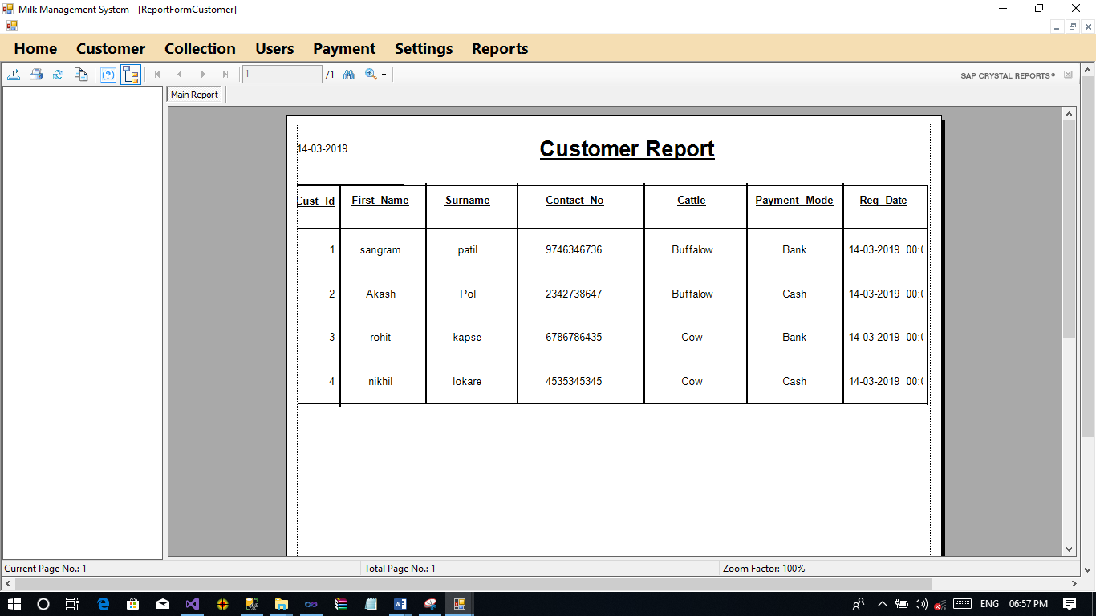

**Customer Bank Account Report**

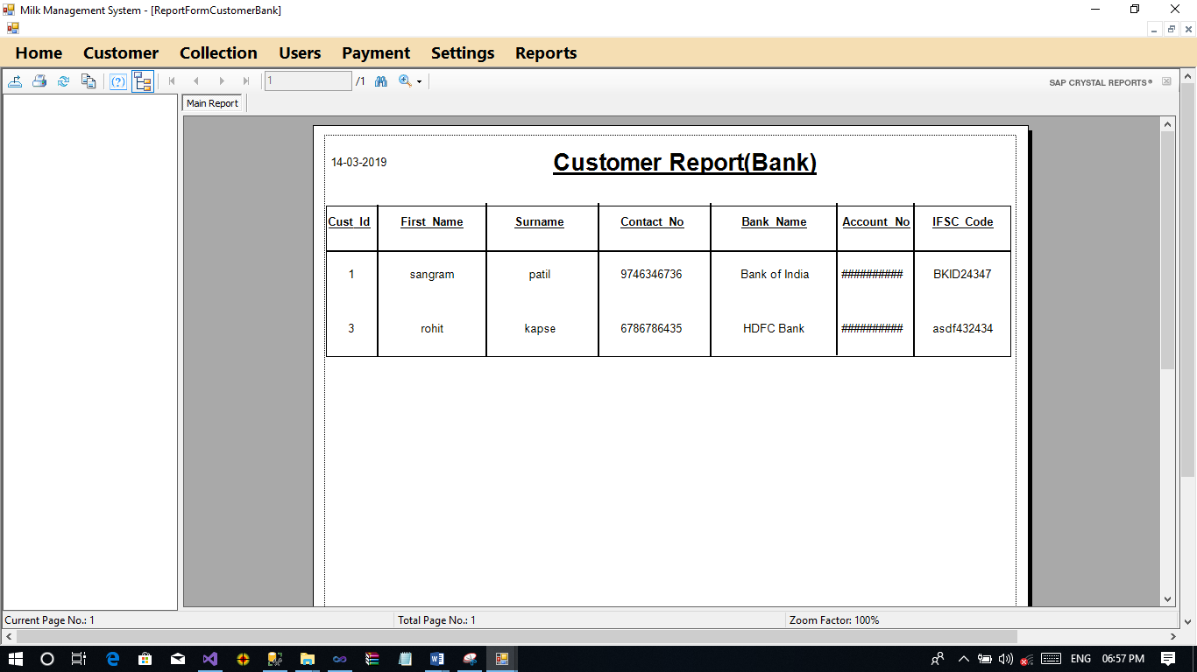

**Paid Payment Report**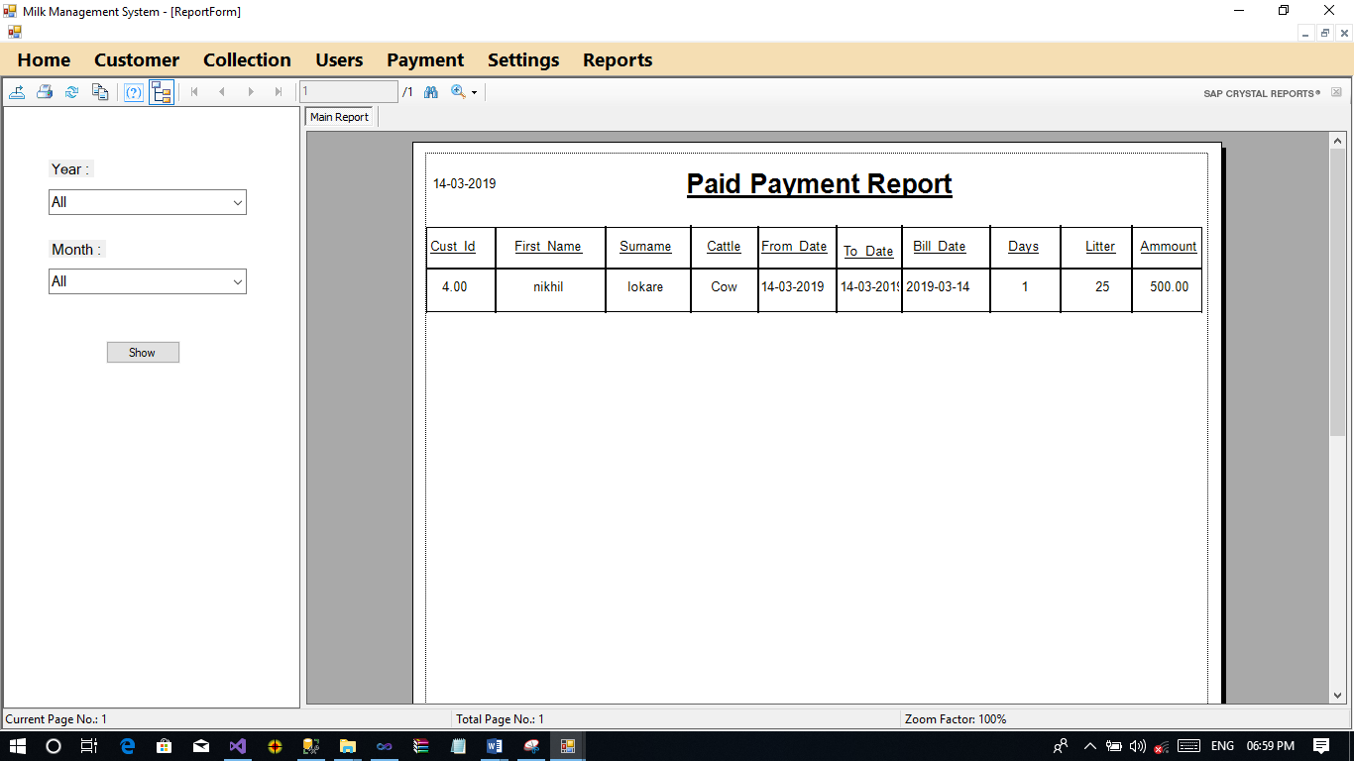

**Unpaid Payment Report**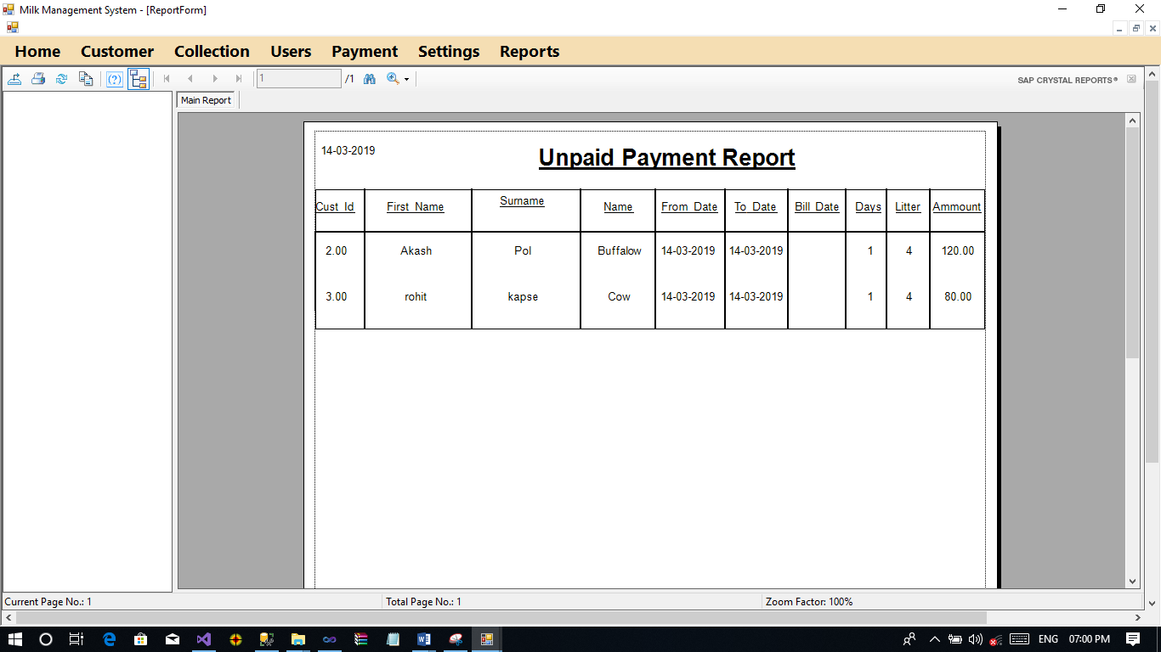

**Milk Collection Report**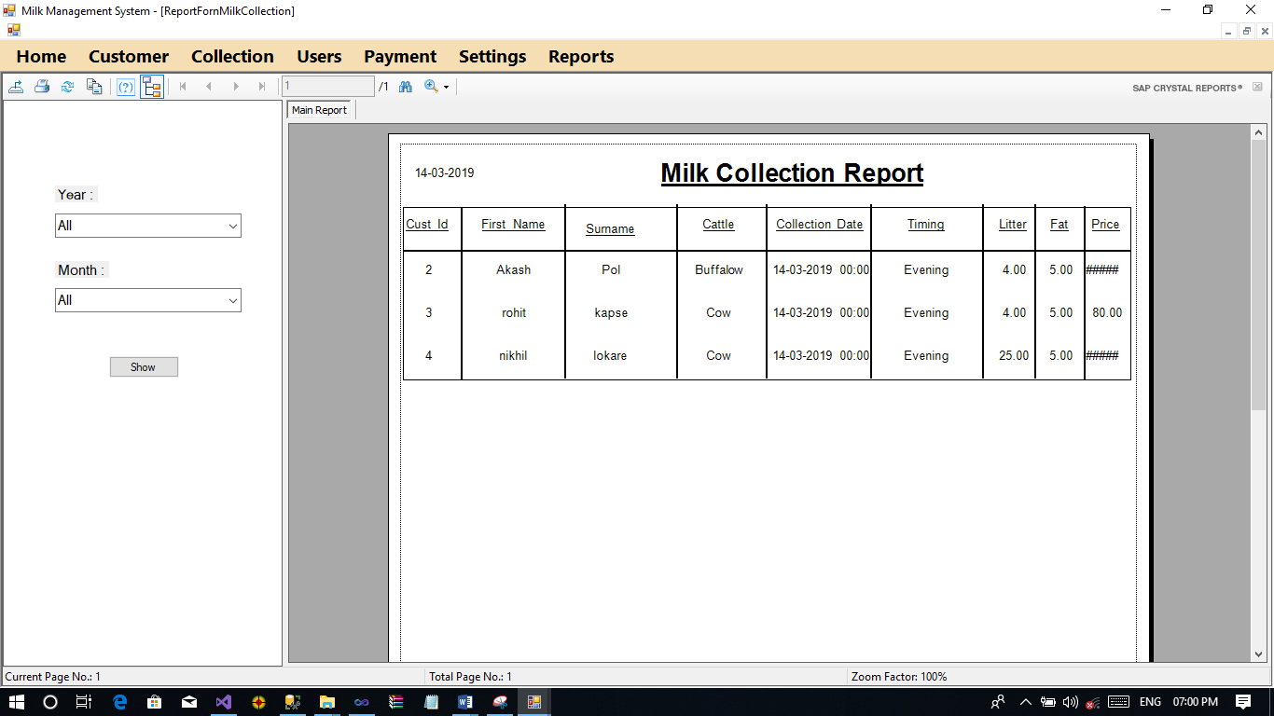

**Advantages & Limitation**

**Advantages**

1. This system is applicable user friendly.
2. It is fast, efficient and reliable
3. Avoids data redundancy and inconsistency
4. Easy accessibility of data.
5. Number of personnel required is considerably less
6. Provides more security and integrity to data

**Limitations**

1. This system is applicable for only Local Milk Dairy Collector.
2. This system cannot support to the online payment.

**Conclusion**

By implementing the project vb. Net and SQL server 2008 this project record for increment of human efficiency by applying the computer resources in the official work. So, we can also say that this is a technology, which is boon for the enterprise section of the world.

The project that we have completed can be used in any with minor modification according to the requirements. In this experienced that for project in with. In this project we have used SQL server 2008.

**References.**

Bibliography:

1] “System, Analysis & Design”

– By Award

2] “Object Oriented Programming & Visual Programming”

- By Mrs. Mansisha Jadhav / Surywanshi

3] “Visual Basic 6.0”

– By Rajendra Salokhe